Managing Insect Pests in Sweet Corn And Minimizing Spraying
Dr. Alan Eaton, UNH Cooperative Extension

I manage a program called IPM --- Integrated Pest Management. The goal is to help farmers (and others) with a difficult balancing act. Sweet corn is a great example, and there are many acres of sweet corn grown in Hollis (plus plenty of people who eagerly eat sweet corn).

Two of the three major caterpillars that attack ears of sweet corn are very unpredictable. They can’t overwinter here, so the adult moths fly in from farther south. In some years there are a lot, and in others there are few. When there are a lot that attack, the only practical way for growers to control them is to use an insecticide. Growers prefer not to use them, but market analysis repeatedly shows that the vast majority of consumers here do NOT want caterpillars in the ears they buy. But wait a minute…those same consumers typically demand that growers not do any spraying! That’s a tough balancing act. Here’s what we do:

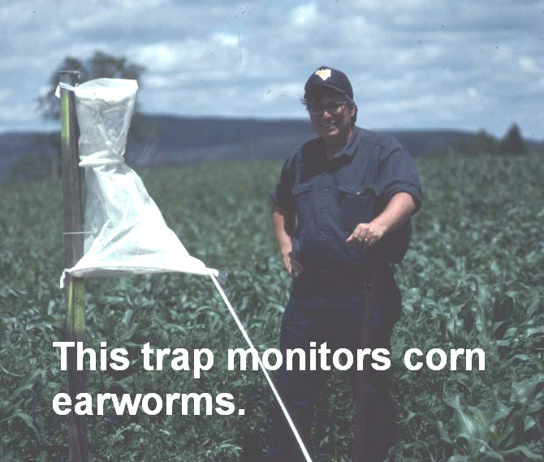
We use an approach to pest problems that combines 1) preventative/suppressive measures, 2) monitoring and 3) controls. Examples of preventative measures for sweet corn insects: destroy crop residues promptly after harvest, and rotate crops. Monitoring: we maintain a network of insect traps (including some in Hollis) to find out when there are significant flights of the moths. This year’s network is still being set up, but you can see the 2010 data (and recommendations) at http://extension.unh.edu/Agric/SCIPM/index.htm Click on any site on the map, and the trap data for that site will be displayed.

Our field scout also checks some sweet corn plants for evidence of feeding, and warns growers, when there is still time to respond.

Controls: Usually growers select chemical insecticides to spray sweet corn insects (corn earworm, Fall armyworm, European corn borer), but there are several biological insecticides, too. There are also chemicals that are approved for organic growers.
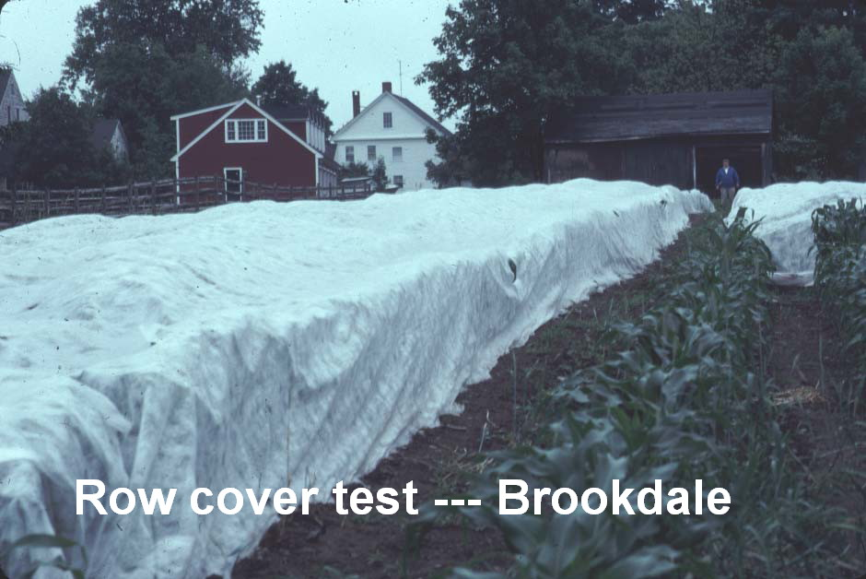
We have tested non-spray choices, too. Row covers can be used to control early season sweet corn insects, but they create some logistics problems. You can’t apply fertilizer, or cultivate to control weeds, if the field is covered by the netting-like material. We tested releasing parasitic wasps to control European corn borer. It worked fairly well, but was very expensive, compared to a couple of sprays of Dipel, a biological insecticide. Also, it didn’t work reliably on Fall armyworm or corn earworm.

What would NH sweet corn growers do if we didn’t offer this program (if our funding is cut, for example)? We found out in the 1990’s, when we stopped the sweet corn IPM program, to concentrate on other new efforts (like greenhouse IPM work, and tick IPM). Most commercial sweet corn growers produce so many crops (30 kinds is common) that they cannot have an employee scout and maintain traps. There are too many more urgent tasks to accomplish on the farm. So…they returned to automatically spraying each field, by the calendar. Spraying went up dramatically. So did the number of damaged ears.
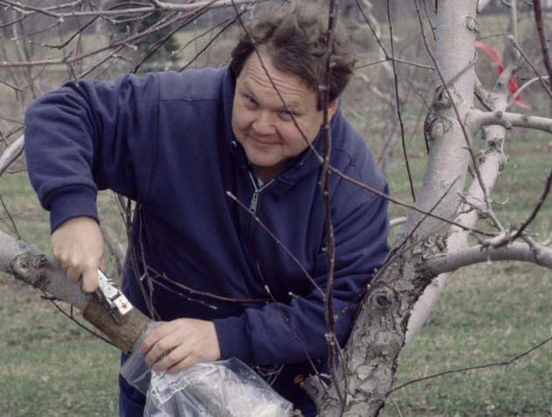
Hillsborough County Extension Educator George Hamilton saw this, and realized that we could return the sweet corn work by applying for an IPM grant to New Hampshire Department of Agriculture, Markets and Food. He did so, and it paid for the traps & lures, and the labor and travel to visit farms and identify the catch. The result was a significant decrease in spraying ($10 to $20/acre decrease) plus a significant decrease in culling. (Culling is throwing out ears that are infested, and therefore can’t be sold).There are other benefits too, that are hard to quantify in dollars. Because growers spray less, there is less risk of environmental contamination, and higher numbers of beneficial insects around to attack pests. Pollinating insects survive in higher numbers. And consumers get plenty of fresh, lower-spray corn, that isn’t infested with caterpillars, and available right here in town. Does it save money? You bet. Sweet corn growers regularly report that they reduced culling by $100,000 to $250,000 (statewide) annually, and typical spray savings are $100,000 statewide.

By the way, in the southeastern states (North Carolina, for example, where I spent three years working on soybean pests) sweet corn typically arrives at supermarket shelves with the tip several inches of each ear chopped off. Why? Despite the very heavy spraying there (heavy pest pressure there), many insects get through and damage the tips of the ears. Marketers learned long ago to chop the tips off, so almost all the ears can be sold.

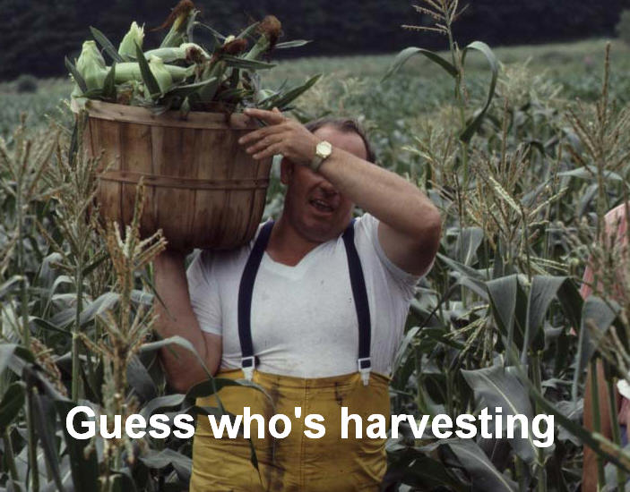
So maybe you’ll see us out there, checking insect traps, counting holes in corn plants, or talking to farmers. We are: Extension Educator George Hamilton, field scout Linda Kuhnhardt, and Extension specialist Alan Eaton, working in partnership with NH Dept of Agriculture, Markets & Food, and your local sweet corn growers. If you have time, we’ll tell you about other work…monitoring ticks that spread diseases, testing traps on blueberry insects, releasing predaceous mites to attack leaf-eating mites…

